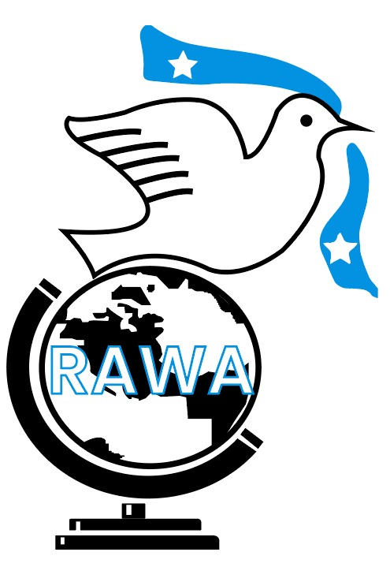

***Contacts***

|  |  |  |
| --- | --- | --- |
| ***Sayid Ali abdi***  Executive Director  Tel No: +252612863388 or +254722685187 | ***Ubah Abdullahi Mohamed***  Programmes coordinator  Tel No: +252618608560 or +254708702112 | Head Quarter: Mogadishu Somalia,  Branches: Galkacyo, Dhusamareeb, Beletweyn, Hobyo, Kismaayo, Baidoa, Hargeisa, Harardhere, Jowhar, and Nairobi  Email: [rawasad@gmail.com](mailto:rawasad@gmail.com) or [org.rawasad@hotmail.com](mailto:org.rawasad@hotmail.com) |

Organizational Profile

Ras-Awad Welfare Association (RAWA)

Table of Contents

Introduction 2

Organogram 3

The Management 4

a. Executive Director: Sayid Ali abdi Hersi 4

b. Programmes Coordinator: Ubah Abdullahi Mohamed 5

Mission and Vision Statement. 6

Our Objectives 7

What We Do? 8

Working Modalities 8

Our Projects 9

## Introduction

Established in 2005, Ras-Awad Welfare Association (RAWA) is a local non-profit organization dedicated to improving the health, nutrition, knowledge and awareness and overall well-being of communities through a variety of programs and initiatives.

Our efforts revolve around Water, Sanitation, and Hygiene (WASH) projects, education and capacity building endeavors, research activities, and advocacy works aimed at supporting underserved populations.

Education holds a special place in RAWA's heart. We strive to broaden access to both primary and secondary education to ensure that every child receives a top-notch learning experience. This entails continuous professional development for educators, enhancing school facilities, and providing essential educational materials. Our emphasis on inclusivity shines through as we tailor educational programs to cater to marginalized groups like pastoralists, displaced individuals, returnees, children with special needs, and girls while ensuring that teaching resources are sensitive to gender differences.

Beyond traditional schooling avenues lies RAWA's commitment to vocational training programs and Accelerated Basic Education (ABE) initiatives. These alternative pathways equip learners with practical skills vital for their future endeavors.

Capacity-building takes center stage at RAWA through workshops for upskilling purposes, policy advocacy training sessions, and mentorship programs. We empower women and youth through specialized initiatives crafted to boost their skills and self-assurance. Public health campaigns play a pivotal role alongside our WASH facility setups and efforts towards raising awareness about food security issues. Additionally providing consultancy services aids in enhancing community health outcomes.

At the core of RAWA's operations lies a dedication to evidence-based decision-making processes. We engage in thorough quantitative and qualitative research methodologies encompassing questionnaires, focus group discussions, key informant interviews as well as document analyses. Monitoring progress coupled with evaluation procedures allows us to gauge the effectiveness of our interventions leading us towards continuous enhancements for greater impact.

## 

## Organogram

***Diagram: RAWA Organogram***

## The Management

### Executive Director: Sayid Ali abdi Hersi

Sayid Ali Abdi Hersi is a seasoned Executive Director renowned for his organized, innovative, and methodical approach to leadership, particularly in the domains of project management and planning. With extensive experience in both government and multinational organizations, he has demonstrated exceptional expertise in providing effective leadership, guidance, and collaboration on various initiatives.

Mr. Hersi's career is marked by a strong track record in managing major projects with prominent international organizations such as UN OCHA, FAO, and WFP. His portfolio includes significant contributions to social practices, human rights preservation, and awareness programs, as well as women and youth empowerment, skills development, education, nutrition, health, and WASH (Water, Sanitation, and Hygiene) projects.

Notably, he has played pivotal roles in high-impact projects with the Government of Somalia and various multinational organizations, ensuring the successful delivery of initiatives that meet the needs and expectations of diverse stakeholders. His academic credentials include a Master’s in Public Administration from Kampala International University and a Bachelor’s Degree in Development Studies.

Mr. Hersi's leadership style is characterized by a commitment to excellence and a collaborative approach, fostering sustainable development and social progress. His innovative strategies and methodical execution make him a highly effective leader in advancing organizational goals and driving positive change across multiple sectors.

## Programmes Coordinator: Ubah Abdullahi Mohamed

Ubah Abdullahi Mohamed, brings a wealth of experience in coordinating and managing projects, showcasing remarkable leadership qualities and a deep dedication to community welfare.

In her previous role as a Project Coordinator for the Ministry of Ports and Fisheries in Galmudug, Ubah orchestrated stakeholder meetings with precision, ensured the integration of gender perspectives into project activities, and crafted effective project strategies. Within RAWA, she has taken on diverse responsibilities such as Project Manager and Finance Officer. In these capacities, she skilfully handled project plans, budgets, and reports while collaborating with donors and partners to ensure projects were completed promptly.

With her proficiency in Microsoft Office complementing her excellent communication skills along with critical thinking and problem-solving abilities, Ubah adeptly oversees RAWA's programs. Her efforts focus on promoting health, nutrition, and overall well-being within marginalized communities.

## Mission and Vision Statement.

|  |  |
| --- | --- |
| Mission: | Vision: |
| To enhance the living standards of Somali communities by fostering self-reliance and prosperity. We achieve this through the provision of relief, rehabilitation, and development programs, and by strengthening local capacities to address their needs in a transparent and participatory manner. | A prosperous and self-reliant Somali society, where empowered communities effectively address their challenges and achieve sustainable development. |

## Our Objectives

* **Improve Community Resilience:**

Enhancing the strength and adaptability of communities in specific areas to tackle different obstacles such as natural calamities, conflicts, and socio-economic struggles. This involves setting up support systems and rallying resources to aid those in need.

* **Promote Self-Reliance:**

Introducing initiatives focused on livelihood and empowerment, tailored to foster independence among people, with a special emphasis on women and youth. This involves honing skills, providing vocational training, and offering entrepreneurial guidance to pave the way for self-sufficiency.

* **Strengthen Local Capacities:**

1. Empower local government bodies, community entities, and various organizations to adeptly tackle and oversee their unique development requirements and obstacles for youths and women.
2. Involve youths and women in the field of health, education, environment and economic activities and programs
3. Enhance access to information on young generation and social development sector

to policy makers and practitioners

## What We Do?

|  |  |  |  |
| --- | --- | --- | --- |
| Capacity Building | WASH Health, Nutrition, Water and Sanitation | Research | Education |
| * Upskilling workshops * Policy and advocacy training * Mentoring partnerships. * Women and Youth empowerment * Vocational training | * Public Health Knowledge and awareness campaigns * WASH facilities setup * Food security awareness and consultancy * Nutrition and health support | * Quantitative (questionnaires) * Qualitative (FGDs, KII’s, and Document reviews’ * Monitoring and evaluation | * Expand primary and secondary education access. * Improve education quality through teacher development, better facilities, and school supplies. * Ensure inclusive education for marginalized groups and provide gender-sensitive teaching materials. * Offer vocational training and Accelerated Basic Education (ABE) programs to provide alternative educational pathways and practical skills. |

## Working Modalities

Our current practices of implementing programs and activities include getting approval from the concerned government agencies (Social Welfare Council). After the approval, induction meeting is conducted with all relevant stakeholders and partners to inform and communicate about the programs. Likewise, communication and coordination are done with local level stakeholders and local partners. Only after approval and coordination with all stakeholders, the program/activities are implemented in the concerned areas.

Diagram: **Working Modalities**

## Our Projects

|  |  |  |  |
| --- | --- | --- | --- |
| Project Name | Description | Partners | Status/Completion Date |
| Ongoing Partnerships | | | |
| Provision of lifesaving preventative nutrition services to build the resilience of IDPs in Daynille, Banadir Region. | Empowered Community Health Workers and households to tackle malnutrition via screening, referral, and the Family MUAC strategy.  Promotes locally sourced nutritious foods and integrates child protection, GBV prevention, PSEA, AAP, and disability inclusion for comprehensive support. | UN-OCHA | June 2024 to present |
| Previous Partnerships | | | |
| Cash for work and UCT | Facilitated a total of 700 vulnerable HH who benefited from a Cash for work and unconditional cash transfers enabling them to sufficiently meet their food requirements and increase their livelihood resilience | FAO | May 2019 - 30th May 2020 |
| Unconditional cash transfer | Assisted 1350 vulnerable HH to access food and enhance community’s capacity to cope with shock | FAO | November 2017to 30th April 2018 |
| Cash for Work and UCT | Supported1000 vulnerable Households with access to cash at disposal program through cash for work activities and unconditional cash transfer to enable them to meet their minimum food requirements. | FAO | July 2018 to 14th April 2018 |
| Target Supplementary Feeding Program (TSFP) | Supported in the reduction of the mortality related with acute malnutrition in the Children aged 6-59 months and the pregnant women & lactating mothers through the management of moderate acute malnutrition, and to prevent further deterioration in affected households’ food security situation through TSFP program. | WFP (World Food Program) | March 2016 to 2019 |
| Water, Sanitation And Hygiene | Facilitated with access to equal, sustainable and safe water to vulnerable pastoral, riverine and urban livelihoods in Xarardheere, Hobyo, Ceeldheer and Buale districts | UN-OCHA | 2013 to 2015 |
| Food Security | Supported with access to food to people in emergency and crises in Buale and Xarardheere districts through food voucher, cash voucher and livelihood investment | UN-OCHA | 2013 to 2015 |

Table: **Current and Previous Partnerships**